SCHEDULING CRITERIA
➢Different cpu scheduling algorithms have different properties.
➢The properties of the various algorithms has to be considered to choose which algorithm is best suited for a particular situation.
➢The criteria include the following:
- CPU utilisation
- Throughput
- Turnaround time
- Waiting time
- Response time
1. CPU utilisation :
- The main objective of any CPU scheduling algorithm is to keep the CPU as busy as possible.
- CPU utilisation can range from 0 to 100 but in a real-time system, it varies from 40 to 90 percent depending on the load upon the system.
- Let assume:
FCFS : cpu utilization is 100%
SJF : cpu utilization is 50%
RR; cpu utilization is 75%
Here FCFS is the best scheduling algorithm by considering CPU utilization.
➢CPU utilization should be maximum. So, the system can make use of cpu in efficient manner than only we can say FCFS is the best algorithm.
- Throughput :
➢Throughput means how many processes are completed its execution per a time unit(time unit may be 1sec or 2sec) is known as Throughput.
➢Let assume: In FCFS algorithm, 5 processes are completed in 1sec, In SJF , 3 processes are completed in 1sec, In Round robin, 9 processes are completed in 1 sec. so here Round Robin is the best algorithm.
➢So, when the cpu is busy executing the process throughput can be maximized.
- Turnaround time:
➢It is a amount of time to execute a particular process.
➢It means the time difference between the time of completion of a process and the time of arrival in the ready queue.
Let assume: a process has been submitted at t0 time in ready queue ,where as cpu has completed the process execution at time t2.
So, TAT=t2-t0 (TAT=Completion time-Arrival time) Here turnaround time should be minimum.
- Waiting time:
➢It specifies how much time a process waits in the ready queue for its execution.
➢Waiting time is a time difference between turnaround time and burst time.
waiting time= t1-t0 (WT=TAT-BT) Here waiting time should be minimized.
- Response time :
➢It is a amount of time in which the request was submitted until the first response is produced.
➢ RESPONSE TIME(RT) =PROCESS STARTING AT FIRST TIME-PROCESS ARRIVAL TIME.
➢Response time should be minimized.

Scheduling Algorithms
➢The main goal of CPU scheduling algorithms is to make sure that the CPU is never in an idle state, meaning that the OS has at least one of the processes ready for execution among the available processes in the ready queue.
The objectives of a scheduling algorithm are as follows:
- Maximize the CPU utilization, means the OS keep the CPU as busy as possible.
- Fair allocation of CPU time to every process
- Maximize the Throughput
- Minimize the turnaround time
- Minimize the waiting time
- Minimize the response time
Types of scheduling Algorithm:
There are mainly six types of process scheduling algorithms.
- First Come First Serve (FCFS)
- Shortest-Job-First (SJF) Scheduling
- Priority Scheduling
- Round Robin Scheduling
- Shortest Remaining Time first
- Multilevel Queue Scheduling
1. First Come First Serve (FCFS)
- Processes/jobs are executed on a first come, first serve basis.
- It is a non-preemptive scheduling algorithm.
- Its implementation is based on FIFO queue.
- It is simple and easy to implement.
- It is a simplest scheduling algorithm that schedules the processes according to arrival times of processes.
Example 1: consider a set of processes arriving at time zero msec.
process | Arrival Time | Burst Time
P1 | 0 | 24
P2 | 0 | 3
p3 | 0 | 3
Here Burst time(BT) : Time required by cpu to execute the process.
Arrival time(AT): time at which the process arrives in the ready queue.
Completion time(CT): time at which process completes its execution.
Gantt chart/time line chart(Generalized activity Normalization time table): It showing a particular schedule, including start and finish time of each process.
p1 | p2 | p3
0 24 27 30
GANTT CHART
process | Arrival  Time | Burst  Time | Completi on time | TAT  time=C T-AT | Waiting  Time  WT=TAT  -BT | Resp onse Time
P1 | 0 | 24 | 24 | 24 | 0 | 0
P2 | 0 | 3 | 27 | 27 | 24 | 24
p3 | 0 | 3 | 30 | 30 | 27 | 27

➢Calculate avg turnaround time and waiting time
Average TAT= Total processes TAT/total no.of process
TAT=24+27+30/3
=81/3
=27ms
Average WT= Total processes WT/total no.of process
WT= 0+24+27/3
=51/3
=33ms
In Non-Preemptive scheduling algorithms, the waiting time(WT) and response time(RT) is same.
But In preemptive , the WT and RT is different.
• Let assume processes are arrival order is : P2, P3, P1
p2 | p3 | p1
0 3 6 30
In this order(p2,p3,p1), p2 & P3 does not wait for the long time for its execution. Because P2 & P3 burst time is 3ms and P1 Burst time is 24ms AWT=6+0+3/3 = 9/3 =3ms.
In this order(p1,p2,p3), p2 & P3 wait for the long time for its execution. Because P1 Burst time is 24ms and P2 & P3 burst time is 3ms and
AWT=6+0+3/3 = 9/3 =33ms.
Example 2
process | Arrival Time | Burst Time
P0 | 0 | 3
P1 | 2 | 6
p2 | 4 | 4
p3 | 6 | 5
p4 | 8 | 2
Gantt chart:
P0 | P1 | P2 | P3 | P4
0 3 9 13 18 20
Avg TAT=3+7+9+12+12/5
process | Arrival  Time | Burst  Time | CT | TAT | WT | Response Time (RT)
P0 | 0 | 3 | 3 | 3 | 0 | 0-0=0
P1 | 2 | 6 | 9 | 7 | 1 | 3-2=1
p2 | 4 | 4 | 13 | 9 | 5 | 9-4=5
p3 | 6 | 5 | 18 | 12 | 7 | 13-6=7
p4 | 8 | 2 | 20 | 12 | 10 | 18-8=10
=43\5 AVG WT=0+1+5+7+10/5
=8.6ms =23/5 = 4.6ms
Disadvantages:
➢If a process has a very high burst time and is coming first, then it will be executed first even if another process with a lesser time is present in the ready state. It is called “convoy effect” problem.
➢It is a poor in performance as average waiting time is high. so.This is not suitable for modern computers.

2. Shortest-Job-First (SJF) Scheduling
Here job means process
➢It is also called as shortest-job-Next(SJN) and it is a non-preemptive scheduling algorithem.
➢A process with the shortest burst time is scheduled first to the cpu it is called SJF/SJN.
➢If two processes have same burst time, then FCFS is used to break the tie.
➢It is best approach to minimize waiting time and response time.
➢In this, the processor(CPU) should know in advance how much time process will take.
Example 1:
PROCESS | ARRIVAL TIME | BURST TIME
P1 | 2 | 1
P2 | 1 | 5
P3 | 4 | 1
P4 | 0 | 6
P5 | 2 | 3
Draw a GANTT Chart:
P4 | P1 | P3 | P5 | P2
0 6 7 8 11 16
➢Here P4 arrives at 0ms in ready queue.
➢Next p1&p3 have same burst time, here we follow FCFS technique. According to FCFS ,P1 first come into the ready queue next P3.
- Next, P5 has shortest burst time i.e 3ms
- Last P2 will be execute because it contain long burst time i.e 5ms.
- Next, Find Completion time, TAT, WT, Response Time(RT).
PROCESS | ARRIVAL TIME | BURST TIME | CT | TAT=CT-AT | WT=TAT-BT | RT
P1 | 2 | 1 | 7 | 5 | 4 | 4
P2 | 1 | 5 | 16 | 15 | 10 | 10
P3 | 4 | 1 | 8 | 4 | 3 | 3
P4 | 0 | 6 | 6 | 6 | 0 | 0
P5 | 2 | 3 | 11 | 9 | 6 | 6
Advantages:
➢Maximum throughput
➢Minimum average waiting and turnaround time ➢Shortest processes will execute first.
➢Better response time than FCFS.
Disadvantages:
➢There is a chance of starvation problem.i.e if shortest processes coming into the ready queue keep executing and longest process blocked for indefinite time that is called starvation.
➢There is also Convoy effect problem.
3. Priority Scheduling:
➢Priority scheduling is a non-preemptive and preemptive scheduling algorithm.
➢The priority assigned to each process. If process with highest priority than it is to be executed first and so on.
➢Processes with same priority are executed on first come first served basis.
➢Priority can be decided based on memory requirements, time requirements or any other resource requirement.
Example 1:
PROCESS | Arrival TIME | PRIORITY | BURST TIME
P0 | 0 | 5 | 10/9
P1 | 1 | 4 | 6/4
P2 | 3 | 2 | 2/2-2=0
P3 | 5 | 0 | 4
Draw a GANTT Chart: Here lesser value is highest priority
P0 | P1 | P2 | P3 | P1 | P0
0 1 3 5 9 13 22
Find CT, TAT, WT, RT, AVG TAT, AVG WT..?
• Example2:
PROCESS | BURST TIME | PRIORITY
P1 | 10 | 3
P2 | 1 | 1
P3 | 2 | 4
P4 | 1 | 5
P5 | 5 | 2
Draw a GANTT Chart:
P2 | P5 | P1 | P3 | P4
⁰ 1 6 16 18 19
Find CT, TAT, WT, RT, AVG TAT, AVG WT..?
Advantages:
➢Higher priority processes execute first.
Disadvantages:
➢This process can cause starvation if high-priority processes take too much CPU time. The lower priority process can also be postponed for an indefinite time.
➢If two processes have the same priorities, than some other scheduling algorithm needs to be used.
➢Starvation is very bad for a process in OS, but we can overcome this starvation problem with the help of AGING Scheduling technique.
➢Aging method involves gradually increasing the priority of processes that wait in the system for along time.
➢Often every 3 unit of time of cpu priority of waiting processes will decrease by 1.
4. Round Robin Scheduling
➢This scheduling algorithm is a preemptive scheduling algorithm .
➢where each process is provided a fixed time to execute. This fixed time is called a Time quantum.
➢It is designed for Time Sharing system so the execution of ready queue must be in form of circular queue.
➢It uses context switching to save states of preempted processes. Once a process is done executing for a given time period, it is preempted and another process executes for a given time period.
➢CPU is alloted to each process for time interval of one time quantum.
➢New processes are added at the end of ready queue.
➢If process has burst time less than a time quantum, the process will release itself of cpu voluntarily after its execution.
➢But, burst time greater than a time quantum, then after the time quantum, interrupt will occur and process will be put at the end of ready queue by executing a context switching.
➢Example : Time quatum is 2ms.
Process | ARRIVAL TIME | BURST TIME
P1 | 0 | 4
P2 | 1 | 5
P3 | 2 | 2
P4 | 3 | 1
P5 | 4 | 6
P6 | 6 | 3
Draw a GANTT Chart: Ready queue:
p1 | p2 | p3 | p1 | p4 | p5 | p2 | p6 | p5 | p2 | p6 | p5

Gantt chart:
process | Arrival time | Burst Time
P1 | 0 | 8
P2 | 0 | 2
P3 | 0 | 7
p4 | 0 | 3
p5 | 0 | 5
p1 | p2 | p3 | p1 | p4 | p5 | p2 | p6 | p5 | p2 | p6 | p5
0 2 4 6 8 9 11 13 ₁₅ 17 18 19 21
Find CT, TAT, WT, RT, AVG TAT, AVG WT..?
Practice Example2:
Advantages: ➢No Convoy effect
➢No Starvation
➢Priority is same for each process
➢Each process gets a fair share of cpu ➢Easy and simple to implement.
Disadvantages:
➢The CPU is left idle due to a lot of context switching.
➢5. Shortest Remaining Time first(SRTF)
➢Shortest Remaining Time First (SRTF) scheduling algorithm is basically a preemptive mode of the Shortest Job First (SJF) algorithm
- In which jobs are scheduled according to the shortest remaining time.
- In this scheduling technique, the process with the shortest burst time is executed first by the CPU, but the arrival time of all processes need not be the same. If another process with the shortest burst time arrives, then the current process will be preempted, and a new process will be executed first.
Example:
Process | Arrival time | Burst time
P1 | 2 | 1
P2 | 1 | 5
P3 | 4 | 1
P4 | 0 | 6/5/4
P5 | 2 | 3/2
Ready Queue:
P4 | P2 | P1 | P5 | P3
Draw Gantt Chart:
p4 | p4 | p1 | p5 | p3 | p5 | p4 | p2
0 1 2 3 4 5 7 11 16
➢First at time 0ms p4 process is entered into ready queue, after 1ms(6-1=5) Here p2 BT is 5ms , p4 BT 5ms. so., here first arrival process is p4 in ready queue. so, again p4 is running.
➢At 2ms process P1&P5 entered into ready queue. But P2 has low Burst time. So, P1 is executed.
➢At 3ms P5 is started its execution and stop P5 execution because at 4ms process P3 is entered into ready queue and it has low burst time. So, now P3 is executed.
➢No need to check after arrival of all the processes into ready queue.
➢Next P5 is executed .because p5 has low BT(i.e. 2ms)
➢Next P4 is executed .because p54has low BT(i.e. 4ms) ➢Next P2 is executed .because p2 has low BT(i.e. 5ms).
- Calculate CT, TAT, WT, RT, Avg TAT, Avg WT..?
- Example 2: For Practice
process | Arrival time | Burst time
P1 | 0 | 8
P2 | 1 | 4
P3 | 2 | 9
p4 | 3 | 5
6. Multilevel Queue Scheduling
➢In this algorithm, partition the ready queue into several separate ready queues.
➢A multilevel queue is suitable when the processes are classified in groups.
➢Each of the processes are permanently assigned to one queue based on some priority.
➢Then each queue has its own scheduling algorithm.
➢For example, CPU-bound jobs can be scheduled in one queue and all I/O-bound jobs in another queue.
➢The Process Scheduler then alternately selects jobs from each queue and assigns them to the CPU based on the algorithm assigned to the queue.
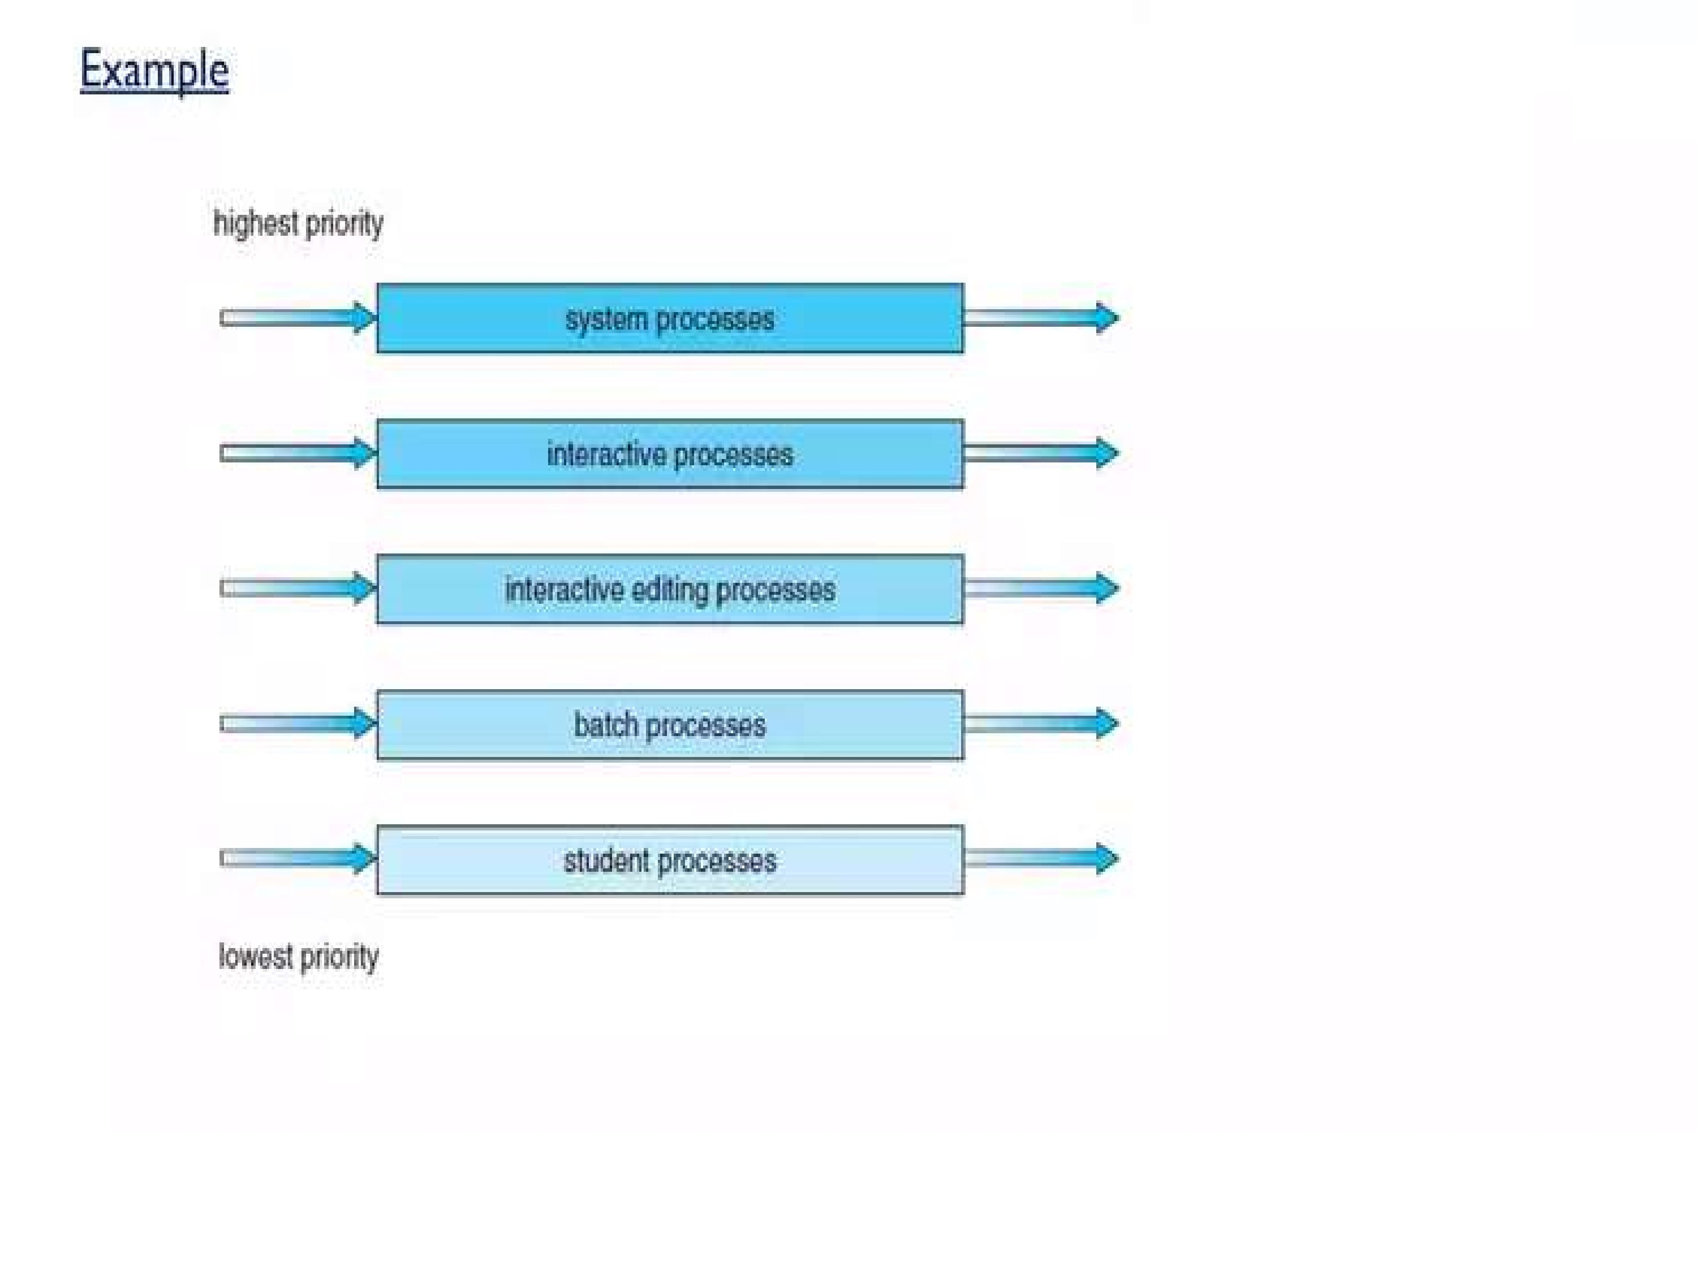
•
Example 2:

Multilevel Feedback Queue scheduling:
➢In Multilevel Feedback Queue Scheduling (MFQS), the processes can move between the queues.
➢There are multiple CPUs available for load sharing. This process helps avoid starvation as if there is a process waiting in the low priority queue can be moved to the high priority queue, and a process taking too much of the CPU time will be shifted to the lower priority queue.
➢MFQS is a flexible scheduling algorithm.
➢It allows the different processes to move between queues.
➢Prevents CPU starvation.
➢It is the most complex scheduling algorithm.
• Example:
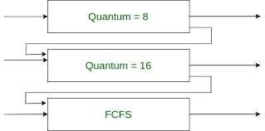

Multiple Processors Scheduling
➢A multi-processor is a system that has more than one processor but shares the same memory, bus, and input/output devices.
➢The bus connects the processor to the RAM, to the I/O devices, and to all the other components of the computer.
➢Multi processor system works even if a processor goes down. The rest of the system keeps working. In multi-processor scheduling, more than one processors(CPUs) share the load to handle the execution of processes smoothly.
Approaches to Multiple Processor Scheduling
➢There are two approaches to multiple processor scheduling in the operating system: Symmetric Multiprocessing and Asymmetric Multiprocessing.
1.Symmetric Multiprocessing(SMP):
➢ In this , a system has more than one processor and each processor has its own private operating system and memory is shared among all the processors and inputoutput system are also shared. All the system is connected by the single bus.
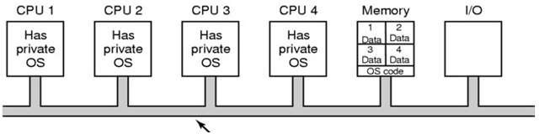
SMP System
➢In SMP, where each processor is self scheduling and All processors are treated equally.
➢Tasks of the OS are done individual processor.
➢All processors communicate with another processor by a shared memory.
➢In SMP, the process is taken from ready queue.
➢SMP systems are costlier and this systems are complex to design.
2. Asymmetric multiprocessing(AMP):
➢It is a multiprocessor interconnected system where not all of the multiple interconnected processors are treated equally.
➢In this , one processor works as master and other processor work as a slave..
➢In this, all the processors are handled by the single processor which is called master server.
➢The master server runs the operating system process and the slave server run the user processes.
➢The memory and I/O devices are shared among all the processors and all the processor are connected to a common bus.
➢ This system is simple and reduces the data sharing so this system is called Asymmetric multiprocessing.
➢AMP systems are easier to design.
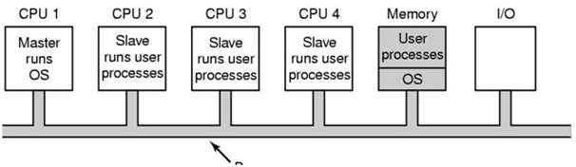
AMP System
Processor Affinity:
➢A process has an affinity for a processor on which it runs.
i.e means systems are try to avoid migration of processes from one processor to another and keep a process running on the same processor. This is known as processor affinity.
➢There are two types of processor affinity
  - Soft Affinity: The system has a rule of trying to keep running a process on the same processor but does not guarantee it. hence some process may migrate between processors. This is called soft affinity.
  - Hard Affinity:
➢Hard Affinity allows a process to specify a subset of processors on which it may run. So, In this, process can’t migrate from one process to another processors. This is called hard affinity.
➢Some Linux systems implement soft affinity and provide system calls like sched_setaffinity() that also support hard affinity.
Load Balancing:
➢An important goal in a multiprocessor system is to balance the load between processors, so that one processor won't be sitting idle while another is overloaded.
➢Load Balancing keeps the workload evenly distributed across all processors in an SMP system.
➢Load balancing is necessary only on systems where each processor has its own private queue of a process that is eligible to execute.
➢There are two general approaches to load balancing:
➢Balancing can be achieved through either push migration or pull migration.
1. Push Migration:
➢ In push migration, a task routinely checks the load on each processor. If it finds an imbalance, it evenly distributes the load on each processor by moving the processes from overloaded to idle or less busy processors.
2. Pull Migration:
➢Pull Migration occurs when an idle processor pulls a waiting task from a busy processor for its execution.
System call interface for process management fork, exit, wait, waitpid, exec.
1. The fork() System Call:
- The fork() is one of the system calls that is very special and useful in Linux/Unix systems.
- Fork() system call is used for creating a new process, which is called child process, which runs concurrently with the parent process (OR)
- Parent process has to wait until the child process completed its execution. So, once the child process execution is terminated than only the parent process has to admitted.
- Child process uses the same pgm counter, registers, open files which use in the parent process.
➢Fork() takes no parameters and returns an integer value. Below are different values returned by fork().
➢Negative value: creation of child process was unsuccessful.
➢Zero: Returned to the newly created child process.
➢Positive value: returned to parent
So, the value contains process ID(PID) of newly created child process.
➢Here parent PID and child PID are different.
➢The returned process ID is of type pid_t defined in sys/types.h. Normally, the process ID is an integer.
➢Aprocess can use function getpid() to retrieve the process ID assigned to this process.
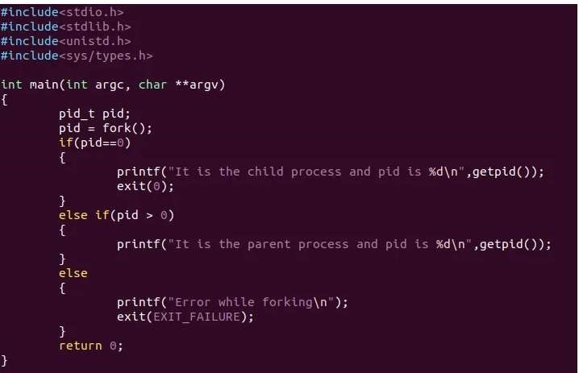
2. exit() System call
➢The exit() is such a function or one of the system calls that is used to terminate the process.
➢This system call defines that the thread execution is completed especially in the case of a multi-threaded environment.
➢After the use of exit() system call, all the resources used in the process are retrieved by the operating system and then terminate the process. The system call Exit() is equivalent to exit().
Synopsis:#include <unistd.h>
void _exit(int status);
#include <stdlib.h> void _Exit(int status);
3. wait() system Call
➢As in the case of a fork, child processes are created and get executed but the parent process is suspended until the child process executes.
➢ In this case, a wait() system call is activated automatically due to the suspension of the parent process. After the child process ends the execution, the parent process has to admitted.
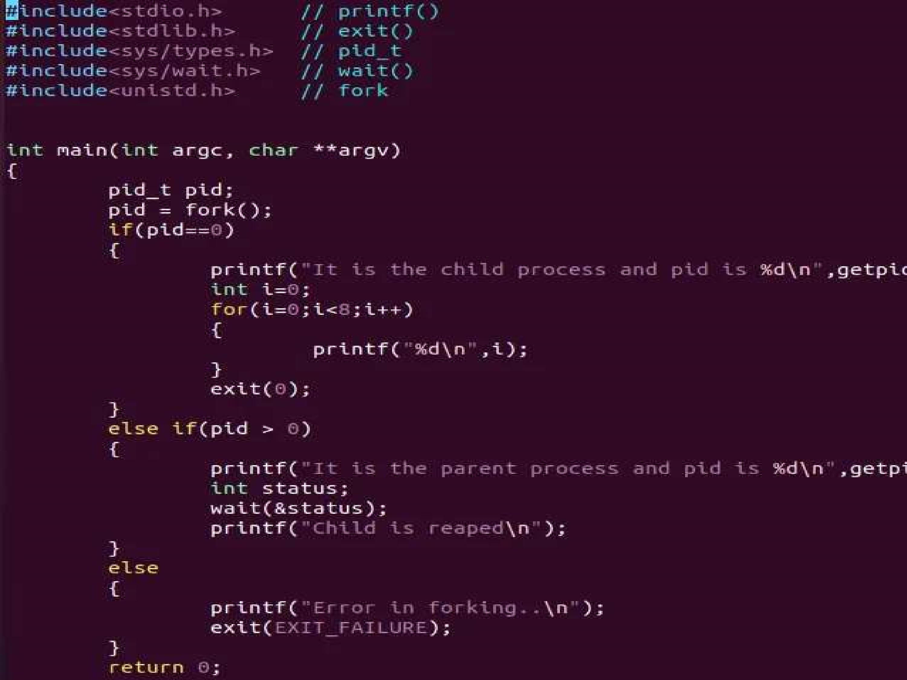
4. exec() System Call
➢The exec() system call that runs by replacing the current process image with the new process image.
➢ However, the original process remains as a new process but the new process replaces the head data, stack data,etc.
➢It runs the program from the entry point by loading the program into the current process space.
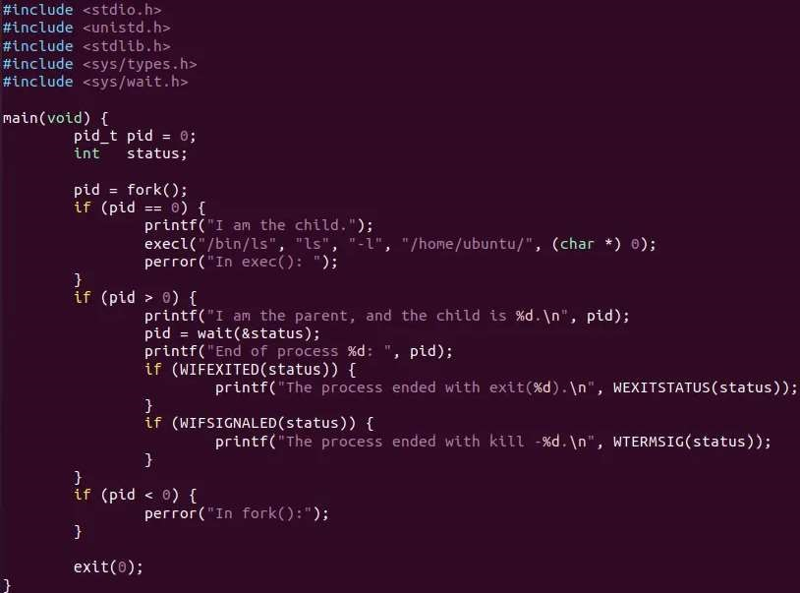
5. waitpid() System Call
➢The waitpid() system call suspends execution of the current process until a child specified by pid argument has changed state.
➢By default, waitpid() waits only for terminated children, but this behaviour is modifiable via the options argument.
➢Syntax of waitpid() :
pid_t waitpid(pid_t pid, int *status, int options);

Deadlocks - System Model
In a multiprogramming environment, process requests resources; if the resources are not available at that time, the process enters a waiting state. Sometimes, a waiting process is never again able to change state, because the resources it has requested by other waiting processes. This situation is called a deadlock.
- A system consists of a finite number of resources to be distributed among a number of competing processes. The resources are partitioned into several types of instances.
- If a process requests an instance of a resource type, the allocation of any instance of the type will satisfy the request.
- If it will not, then the instances are not identical, and the resource type classes have not been defined properly.
For example, a system may have two printers. These two printers may be defined to be in the same resource class if no one cares which printer prints which output. However, if one printer is on the ninth floor and the other is in the basement, then people on the ninth floor may not see both printers as equivalent, and separate resource classes may need to be defined for each printer.
- A process must request a resource before using it and must release the resource after using it. A process may request as many resources as it requires to carry out its designated task.
- Obviously, the number of resources requested may not exceed the total number of resources available in the system.
- In other words, a process cannot request three printers if the system has only two.
Example: Bridge Crossing
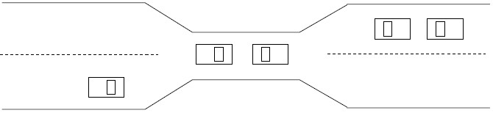
- Traffic only in one direction.
- Each section of a bridge can be viewed as a resource.
- If a deadlock occurs, it can be resolved if one car backs up (preempt resources and rollback).
- Several cars may have to be backed up if a deadlock occurs. ➢ Starvation is possible
A process may utilize a resource in only the following sequence:
- Request: The process requests the resource. If the request cannot be granted immediately (for example, if the resource is being used by another process), then the requesting process must wait until it can acquire the resource.
- Use: The process can operate on the resource (for example, if the resource is a printer, the process can print on the printer).
- Release: The process releases the resource.
Deadlocks Characterization
Necessary Conditions: -
A deadlock situation can arise if the following four conditions hold simultaneously in a system:
- Mutual exclusion. At least one resource must be held in a non-sharable mode; that is, only one process at a time can use the resource. If another process requests that resource, the requesting process must be delayed until the resource has been released.
- Hold and wait. A process must be holding at least one resource and waiting to acquire additional resources that are currently being held by other processes.
- No preemption. Resources cannot be preempted; that is, a resource can be released only voluntarily by the process holding it, after that process has completed its task.

- Circular wait: A set { P0 , Pl, ... , Pn } of waiting processes must exist such that Po is waiting for a resource held by P1, P1 is waiting for a resource held by P2, ... , Pn-1 is waiting for a resource held by Pn, and Pn is waiting for a resource held by Po.
We emphasize that all four conditions must hold for a deadlock to occur. The circular-wait condition implies the hold-and-wait condition, so the four conditions are not completely independent.
Resource-Allocation Graph: -
- Deadlocks can be described more precisely in terms of a directed graph called a graph. This graph consists of a set of vertices V and a set of edges E.
- The set of vertices V is partitioned into two different types of nodes:
P == { P1, P2, ..., P_{n}}, the set consisting of all the active processes in the system, and
R == {R1, R2..., R_{m}} the set consisting of all resource types in the system
- A directed edge from process P_{i} to resource type R_{j} is denoted by P_{i} R_{j}; it signifies that process P_{i} has requested an instance of resource type R_{j} and is currently waiting for that resource.
- A directed edge from resource type R_{j} to process P_{i} is denoted by R_{j} P_{i}; it signifies that an instance of resource type R_{j} has been allocated to process P_{i.}
- A directed edge P_{i} R_{j} is called a request edge; a directed edge R_{j} P_{i} is called an assignment edge.
- Pictorially we represent each process Pi as a circle and each resource type Rj as a rectangle.
- Since resource type Rj may have more than one instance, we represent each such instance as a dot within the rectangle.
- Note that a request edge points to only the rectangle R1, whereas an assignment edge must also designate one of the dots in the rectangle.
- When process Pi requests an instance of resource type Rj, a request edge is inserted in the resource-allocation graph.
- When this request can be fulfilled, the request edge is instantaneously transformed to an assignment edge. When the process no longer needs access to the resource, it releases the resource; as a result, the assignment edge is deleted.

The resource-allocation graph shown in Figure: A depicts the following situation.
The sets P, K and E:
Set of processes P = {P1, P2, P3}
Set of resorcesses R= {R1, R2, R3, R4}
Edges E = {Pl Rl , P2 R3, Rl P2, R2 P2, R2 Pl, R3 P3} Resource Instances:
- One instance of resource type R1
- Two instances of resource type R2
- One instance of resource type R3
- Three instances of resource type R4 Process States:
- Process P1 is holding an instance of resource type R2 and is waiting for an instance of resource type R1.
- Process P2 is holding an instance of R1 and an instance of R2 and is waiting for an instance of R3.
- Process P3 is holding an instance of R3

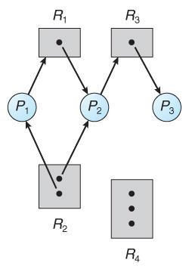
Figure: A Resource-allocation graph.
- If a resource-allocation graph contains no cycles, then the system is not deadlocked.
- If a resource-allocation graph does contain cycles AND each resource category contains only a single instance, then a deadlock exists.
- If a resource category contains more than one instance, then the presence of a cycle in the resource-allocation graph indicates the possibility of a deadlock, but does not guarantee one.
To illustrate this concept, we return to the resource-allocation graph depicted in Figure A.
Suppose that process P3 requests an instance of resource type R2. Since no resource instance is currently available, a request edge P3 R2 is added to the graph (Figure: B). At this point, two minimal cycles exist in the system:
P1 R1 P2 R3 P3 R2 P1
P2 R3 P3 R2 P2
- Processes P1, P2, and P3 are deadlocked. Process P2 is waiting for the resource R3, which is held by processP3. Process P3 is waiting for either process P1 or process P to release resource R2. In addition, process P1 is waiting for process P2 to release resource R1.
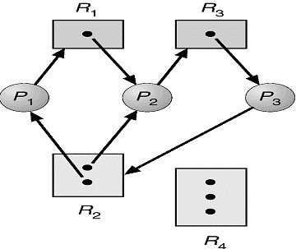
Figure B: Resource-allocation graph with a deadlock.

Now consider the resource-allocation graph in Figure C. In this example, we also have a cycle:
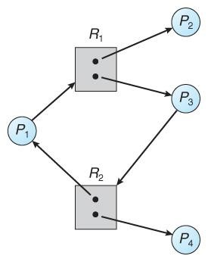

P1

R1

P3

R2

P1

Figure C: Resource-allocation graph with a cycle but no deadlock.
- However, there is no deadlock. Observe that process P4 may release its instance of resource type R2. That resource can then be allocated to P3, breaking the cycle.
- In summary, if a resource-allocation graph does not have a cycle, then the system is not in a deadlocked state.
- If there is a cycle, then the system may or may not be in a deadlocked state.
- This observation is important when we deal with the deadlock problem.

Methods of Handling Deadlocks
Generally speaking, we can deal with the deadlock problem in one of three ways:
- We can use a protocol to prevent or avoid deadlocks, ensuring that the system will never enter a deadlocked state.
- We can allow the system to enter a deadlocked state, detect it, and recover.
- We can ignore the problem altogether and pretend that deadlocks never occur in the system. The third solution is the one used by most operating systems, including UNIX and Windows; it is then up to the application developer to write programs that handle deadlocks.

Deadlock Prevention
❖ Deadlock provides a set of methods for ensuring that at least one of the necessary conditions cannot hold. We elaborate on this approach by examining each of the four necessary conditions separately.
- Mutual Exclusion:
  - The mutual-exclusion condition must hold for non-sharable resources.
  - For example, a printer cannot be simultaneously shared by several processes.
  - Sharable resources, in contrast, do not require mutually exclusive access and thus cannot be involved in a deadlock.
  - Read-only files are a good example of a sharable resource. If several processes attempt to open a read-only file at the same time, they can be granted simultaneous access to the file.
  - A process never needs to wait for a sharable resource.
  - In general, however, we cannot prevent Deadlocks by denying the mutual-exclusion condition, because some resources are intrinsically non-sharable.
- Hold and Wait:
  - To ensure that the hold-and-wait condition never occurs in the system, we must
guarantee that, whenever a process requests a resource, it does not hold any other resources.
  - One protocol that can be used requires each process to request and be allocated all its resources before it begins execution.
  - An alternative protocol allows a process to request resources only when it has none. A process may request some resources and use them.
  - Before it can request any additional resources, however, it must release all the resources that it is currently allocated.
Example: To illustrate the difference between these two protocols, we consider --
    - First method, a process that copies data from a DVD drive to a file on disk, sorts the file, and then prints the results to a printer.
    - If all resources must be requested at the beginning of the process, then the process must initially request the DVD drive, disk file, and printer.
    - It will hold the printer for its entire execution, even though it needs the printer only at the end.
    - The second method allows the process to request initially only the DVD drive and disk file.
    - It copies from the DVD drive to the disk and then releases both the DVD drive and the disk file.
    - The process must then again request the disk file and the printer. After copying the disk file to the printer, it releases these two resources and terminates.
  - Both these protocols have two main disadvantages.
    - First, resources may be allocated but unused for a long period. In the example we can release the DVD drive and disk file, and then again request the disk file and printer, only if we can be sure that our data will remain on the disk file. Otherwise, we must request all resources at the beginning for both protocols.
    - Second, starvation is possible. A process that needs several popular resources may have to wait indefinitely, because at least one of the resources that it needs is always allocated to some other process.
- No Preemption:
  - The third necessary condition for deadlocks is that there be no preemption of resources that have already been allocated. To ensure that this condition does not hold, we can use the following protocol.
  - If a process is holding some resources and requests another resource that cannot be immediately allocated to it (that is, the process must wait), then all resources the process is currently holding are preempted.
  - Alternatively, if a process requests some resources, we first check whether they are available. If they are, we allocate them. If they are not, we check whether they are allocated to some other process that is waiting for additional resources.
  - If so, we preempt the desired resources from the waiting process and allocate them to the requesting process.
  - If the resources are neither available nor held by a waiting process, the requesting process must wait. While it is waiting, some of its resources may be preempted, but only if another process requests them.
  - A process can be restarted only when it is allocated the new resources it is requesting and recovers any resources that were preempted while it was waiting.
- Circular Wait:

  - The fourth and final condition for deadlocks is the circular-wait condition. One way to ensure that this condition never holds.
  - Circular wait: there exists a set {P₀, P₁, …, P_{n}} of waiting processes such that P₀ is waiting for a resource that is held by P_{1.}
  - P₁ is waiting for a resource that is held by P₂, …, P_{n–1} is waiting for a resource that is held by P_{n}, and P_{n} is waiting for a resource that is held by P₀.
Deadlock Avoidance:
The simplest and most useful model requires that each process declare the maximum number of resources of each type that it may need. Given this a priori information, it is possible to construct an algorithm that ensures that the system will never enter a deadlocked state. Such an algorithm defines the deadlock-avoidance approach. I. Safe state:
  - A state is safe if the system can allocate resources to each process (up to its maximum) in some order and still avoid a deadlock.
  - A sequence of processes <P1, P2, ... , Pn> is a safe sequence for the current allocation state if, for each Pi, the resource requests that Pi can still make can be satisfied by the currently available resources plus the resources held by all Pj, with j < i.
  - In this situation, if the resources that Pi needs are not immediately available, then Pi can wait until all Pj have finished.
  - When they have finished, Pi can obtain all of its needed resources, complete it, and return its allocated resources, and terminate.
  - If no such sequence exists, then the system state is said to be unsafe.
  - A safe state is not a deadlocked state. Not all unsafe states are deadlocks, however (Figure
D).
  - An unsafe state may lead to a deadlock. As long as the state is safe, the operating system can avoid unsafe (and deadlocked) states.
  - In an unsafe state, the operating system cannot prevent processes from requesting resources in such a way that a deadlock occurs.
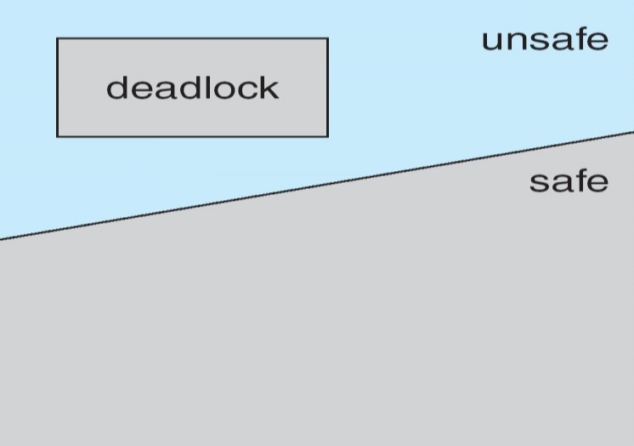

Figure D: Safe, unsafe, and deadlocked state spaces.
To illustrate, we consider a system with twelve magnetic tape drives and three processes: P0, P1, and P2.
  - Process P0 requires ten tape drives, process P1 may need as many as four tape drives.
  - Process P2 may need up to nine tape drives.
  - Suppose that, at time t0, process P0 is holding five tape drives, process P1 is holding two tape drives, and process P2 is holding two tape drives. (Thus, there are three free tape drives.)
Maximum Needs Current Needs
P0 10 5
P1 4 2
P2 9 2
  - At time t0, the system is in a safe state. The sequence <P1, P0, P2> satisfies the safety condition.
  - Process P1 can immediately be allocated all its tape drives and then return them (the system will then have five available tape drives).
  - Then process P0 can get all its tape drives and return them (the system will then have ten available tape drives). Finally process P2 can get all its tape drives and return them (the system will then have all twelve tape drives available).
  - Given the concept of a safe state, we can define avoidance algorithms that ensure that the system will never deadlock. The idea is simply to ensure that the system will always remain in a safe state. Initially, the system is in a safe state.
  - Whenever a process requests a resource that is currently available, the system must decide whether the resource can be allocated immediately or whether the process must wait. The request is granted only if the allocation leaves the system in a safe state.
- The resource-allocation-graph:
  - Observe The resource-allocation-graph (above mentioned topic), In addition to the request and assignment edges already described, we introduce a new type of edge, called a claim edge.
  - A claim edge Pi Rj indicates that process Pi may request resource Rj at some time in the future. This edge resembles a request edge in direction but is represented in the graph by a dashed line.
  - When process Pi requests resource R1, the claim edge Pi Rj is converted to a request edge. Similarly, when a resource Rj is released by Pi, the assignment edge Rj Pi is reconverted to a claim edge
Pi Rj.
The resource-allocation-graph algorithm:is not applicable to a resource allocation system with multiple instances of each resource type. The deadlock avoidance algorithm that we describe next is applicable to such a system but is less efficient than the resource-allocation graph scheme.
This algorithm is commonly known as the banker's algorithm.

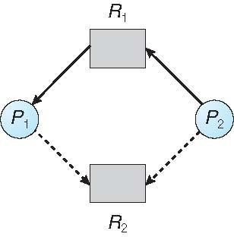
Resource-Allocation Graph

- Banker's Algorithm:
  - The name was chosen because the algorithm could be used in a banking system to ensure that the bank never allocated its available cash in such a way that it could no longer satisfy the needs of all its customers.
  - When a new process enters the system, it must declare the maximum number of instances of each resource type that it may need. This number may not exceed the total number of resources in the system.
  - When a user requests a set of resources, the system must determine whether the allocation of these resources will leave the system in a safe state. If it will, the resources are allocated; otherwise, the process must wait until some other process releases enough resources.

Several data structures must be maintained to implement the banker's algorithm. We need the following data structures, where n is the number of processes in the system and m is the number of resource types:
- Available: A vector of length m indicates the number of available resources of each type.
If Available[ j] equals k, then k instances of resource type Rj are available.
- Max: An n x m matrix defines the maximum demand of each process.
If Max[ i] [ j] equals k, then process Pi may request at most k instances of resource type Rj.
- Allocation: An n x m matrix defines the number of resources of each type currently allocated to each process.
If Allocation[ i][ j] equals k, then process Pi is currently allocated k instances of resource type Rj.
- Need: An n x m matrix indicates the remaining resource need of each process.
If Need [ i ][ j ] equals k, then process Pi may need k more instances of resource type Rj to complete its task.
Note that Need[ i][ j] equals Max[ i][ j] - Allocation [ i][ j].
a) Safety Algorithm:
We can now present the algorithm for finding out whether or not a systern is in a safe state.
This algorithm can be described as follows:
- Let Work and Finish be vectors of length m and n, respectively. Initialize
Work= Available and Finish[ i] = false for i = 0, 1, ... , n - 1.
- Find an index i such that both
    - Finish[ i] = =false
    - Need_{i} < Work
If no such i exists, go to step 4.
- Work = Work + Allocation;
Finish[ i ] = true Go to step 2.
- If Finish[ i] = = true for all i, then the system is in a safe state.
This algorithm may require an order of m x n2 operations to determine whether a state is safe. b) Resource-Request Algorithm:
Next, we describe the algorithm for determining whether requests can be safely granted.
Let Request_{i} be the request vector for process P_{i .} If Request_{i} [ j] = = k, then process Pi wants k instances of resource type Rj. When a request for resources is made by process Pi , the following actions are taken:
  - If Request_{i} < Need_{i}, go to step 2. Otherwise, raise an error condition, since the process has exceeded its maximum claim.

  - If Request_{i} < Available, go to step 3. Otherwise, Pi must wait, since the resources are not available.
  - Have the system pretend to have allocated the requested resources to process Pi by modifyil1.g the state as follows: Available= Available - Request_{i} ;
Allocation_{i} =Allocation_{i} + Request_{i} ;
Need_{i} =Need_{i} - Request_{i};
If the resulting resource-allocation state is safe, the transaction is completed, and process P_{i} is allocated its resources. However, if the new state is unsafe, then Pi must wait for Request_{i} , and the old resource-allocation state is restored.
Illustrative Example:
To illustrate the use of the banker's algorithm,
Consider a system with five processes Po through P4 and three resource types A, B, and C. Resource type A has ten instances, resource type B has five instances, and resource type C has seven instances. Suppose that, at time T0 , the following snapshot of the system has been taken:

Allocation Maximum Available
A B C A B C A B C
P0 0 1 0 7 5 3 3 3 2
P1 2 0 0 3 2 2
P2 3 0 2 9 0 2
P3 2 1 1 2 2 2
P4 0 0 2 4 3 3

The content of the matrix Need is defined to be Maximum – Allocation.
Need = Maximum - Allocation
Need
A B C
P0 7 4 3
P1 1 2 2
P2 6 0 0
P3 0 1 1
P4 4 3 1
We need to find the safety sequence:
P0: | Need₀ < Work => (7,4,3) < (3,3,2) ; Finish[ 0] = false
P1: | Need₁ < Work => (1,2,2) < (3,3,2) ; Finish[ 1] = True then
 | Work = Work + Allocation
 | Work = (3, 3, 2) + ( 2,0,0) = (5,3,2)
P2: | Need₂ < Work => (6,0,0) < (5,3,2) ; Finish[ 2] = false
P3: | Need₃ < Work => (0, 1, 1) < (5, 3, 2) ; Finish[ 3] = True then
 | Work = Work + Allocation
 | Work = (5, 3, 2) + (2, 1, 1) = (7, 4, 3)
P4: | Need₄ < Work => (4, 3, 1) < (7, 4, 3); Finish [4] = True then
 | Work = Work + Allocation
 | Work = (7, 4, 3) + (0, 0, 2) = (7, 4, 5)
P0: | Need₀ < Work => (7, 4, 3) < (7, 4, 5); Finish [0] = True then
 | Work = Work + Allocation
 | Work = (7, 4, 5) + (0, 1, 0) = (7, 5, 5)
P2: | Need₂ < Work => (6, 0, 0) < (7, 5, 5); Finish [2] = True then
 | Work = Work + Allocation
 | Work = (7, 5, 5) + (3, 0, 2) = (10, 5, 7).

- We claim that the system is currently in a safe state. Indeed, the Sequence <P1, P3, P4, P0, P2> satisfies the safety criteria.
- Suppose now that process P1 requests one additional instance of resource type A and two instances of resource type C, so Request1 = (1,0,2).
- To decide whether this request can be immediately granted, we first check that Request₁
≤ Available, that is, that (1,0,2) ≤ (3,3,2), which is true.
- We then pretend that this request has been fulfilled, and we arrive at the following new state:
 | Allocation | Need | Available
 | A B C | A B C | A B C
P0 | 0 1 0 | 7 4 3 | 2 3 0
P1 | 3 0 2 | 0 2 0
P2 | 3 0 2 | 6 0 0
P3 | 2 1 1 | 0 1 1
P4 | 0 0 2 | 4 3 1

- We must determine whether this new system state is safe. To do so, we execute our safety algorithm and find that the sequence <P1, P3, P4, P0, P2> satisfies the safety requirement. Hence, we can immediately grant the request of process P1.
- However, that when the system is in this state, a request for (3,3,0) by P4 cannot be granted, since the resources are not available.
i.e. we first check that Request4 ≤ Available, that is, that (3,3,0) ≤ (2,3,0), which is false.
- Furthermore, a request for (0,2,0) by P0 cannot be granted, even though the resources are available, since the resulting state is unsafe.
i.e we first check that Request₀ ≤ Available, that is, that (0,2,0) ≤ (2,3,0), which is true.
But we don’t have a safety sequence if we grant the resources for P0 immediately.
Example 2: Consider the following snapshot of a system:

Allocation Max
A B C D A B C D
P0 3 0 1 4 5 1 1 7
P1 2 2 1 0 3 2 1 1
P2 3 1 2 1 3 3 2 1
P3 0 5 1 0 4 6 1 2
P4 4 2 1 2 6 3 2 5
Using the banker’s algorithm, determine whether or not each of the following states is unsafe. If the state is safe, illustrate the order in which the processes may complete. Otherwise, illustrate why the state is

unsafe.

- Available = (0, 3, 0, 1)

- Available = (1, 0, 0, 2)

Example 3: Consider the following snapshot of a system:

Allocation Max Available
A B C D A B C D A B C D
P0 2 0 0 1 4 2 1 2 3 3 2 1

P1 3 1 2 1 5 2 5 2

P2 2 1 0 3 2 3 1 6

P3 1 3 1 2 1 4 2 4
P4 1 4 3 2 3 6 6 5

Answer the following questions using the banker’s algorithm:

- Illustrate that the system is in a safe state by demonstrating an order in which the processes may complete.

- If a request from process P1 arrives for (1, 1, 0, 0), can the request be granted immediately?

- If a request from process P4 arrives for (0, 0, 2, 0), can the request be granted immediately?

Example 4: Consider the following snapshot of a system:
Allocation Max Available
ABCD ABCD ABCD
Po 0012 0012 1520
Pl 1000 1750
P2 1354 2356
P3 0632 0652
P4 0014 0656
Answer the following questions using the banker's algorithm:
- What is the content of the matrix Need?
- Is the system in a safe state?
- If a request from process P1 arrives for (0, 4, 2, 0), can the request be granted immediately?

Deadlock Detection
If a system does not employ either a deadlock-prevention or a deadlock avoidance algorithm, then a deadlock situation may occur. In this environment, the system may provide:
- An algorithm that examines the state of the system to determine whether a deadlock has occurred
- An algorithm to recover from the deadlock
1. Single Instance of Each Resource Type:
If all resources have only a single instance, then we can define a deadlock detection algorithm that uses a variant of the resource-allocation graph, called a wait-for graph. We obtain this graph from the resource-allocation graph by removing the resource nodes and collapsing the appropriate edges.
- More precisely, an edge from Pi to Pj in a wait-for graph implies that process Pi is waiting for process Pj to release a resource that Pi needs.
- An edge Pi → Pj exists in a wait-for graph if and only if the corresponding resource allocation graph contains two edges Pi → Rq and Rq → Pj for some resource Rq . In Figure 5-A, we present a resource-allocation graph and the corresponding wait-for graph.

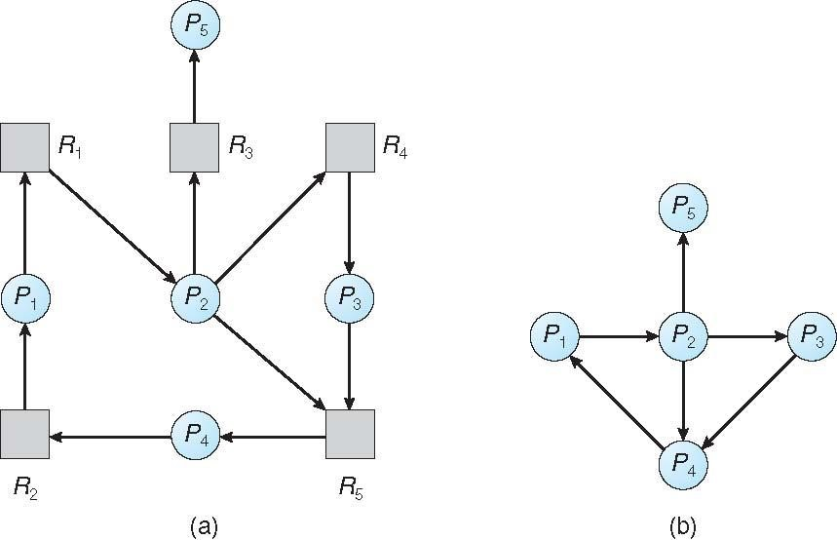
(a) Resource-allocation graph. (b) Corresponding wait-for graph Figure 5-E

- Several Instances of a Resource Type:
The wait-for graph scheme is not applicable to a resource-allocation system with multiple instances of each resource type. We turn now to a deadlock detection algorithm that is applicable to such a system.

Deadlock Detection Algorithm:
  - Let Work and Finish be vectors of length m and n, respectively. Initialize
Work = Available. For i = 0, 1, ..., n–1, if Allocation_{i} = 0, then Finish[i] = false. Otherwise, Finish[i] = true.
  - Find an index i such that both
    - Finish[ i] == false
    - Request_{i} ≤ Work
If no such i exists, go to step 4.
- Work = Work + Allocation_{i}
    - Finish[ i] = true
    - Go to step 2.
- If Finish [ i] = = false for some i, 0≤i<n, then the system is in a deadlocked state. Moreover, if Finish[ i] = = false, then process Pi is deadlocked.
You may wonder why we reclaim the resources of process Pi (in step 3) as soon as we determine that Request_{i} ≤ Work (in step 2b). We know that Pi is currently not involved in a deadlock (since Request_{i} ≤ Work). Thus, we take an optimistic attitude and assume that Pi will require no more resources to complete its task; it will thus soon return all currently allocated resources to the system. If our assumption is incorrect, a deadlock may occur later. That deadlock will be detected the next time the deadlock-detection algorithm is invoked.

To illustrate this algorithm, we consider a system with five processes P0 through P4 and three resource types A, B, and C. Resource type A has seven instances, resource type B has two instances, and resource type C has six instances. Suppose that, at time T0, we have the following resource-allocation state:
 | Allocation | Request | Available
 | A B C | A B C | A B C
P0 | 0 1 0 | 0 0 0 | 0 0 0
P1 | 2 0 0 | 2 0 2
P2 | 3 0 3 | 0 0 0
P3 | 2 1 1 | 1 0 0
P4 | 0 0 2 | 0 0 2

- We claim that the system is not in a deadlocked state. Indeed, if we execute our algorithm, we will find that the sequence <P0, P2, P3, P1, P4> results in Finish[ i] = = true for all i.

- Suppose now that process P2 makes one additional request for an instance of type C. The Request matrix is modified as follows:
Request
 | A B C
P0 | 0 0 0
P1 | 2 0 2
P2 | 0 0 1
P3 | 1 0 0
P4 | 0 0 2
- We claim that the system is now deadlocked. Although we can reclaim the resources held by process P0, the number of available resources is not sufficient to fulfill the requests of the other processes. Thus, a deadlock exists, consisting of processes P1, P2, P3, and P4.

Detection-Algorithm Usage:

When should we invoke the detection algorithm? The answer depends on two factors:
- How often is a deadlock likely to occur?
- How many processes will be affected by deadlock when it happens?
If deadlocks occur frequently, then the detection algorithm should be invoked frequently. Resources allocated to deadlocked processes will be idle until the deadlock can be broken. In addition, the number of processes involved in the deadlock cycle may grow.

Recovery from Deadlock
When a detection algorithm determines that a deadlock exists, several alternatives are available.
- One possibility is to inform the operator that a deadlock has occurred and to let the operator deal with the deadlock manually.
- Another possibility is to let the system recover from the deadlock automatically.

❖ There are two options for breaking a deadlock.

- One is simply to abort one or more processes to break the circular wait.
- The other is to preempt some resources from one or more of the deadlocked processes.

1. Process Termination:
To eliminate deadlocks by aborting a process, we use one of two methods. In both methods, the system reclaims all resources allocated to the terminated processes.
- Abort all deadlocked processes. This method clearly will break the deadlock cycle, but at great expense. The deadlocked processes may have computed for a long time, and the results of these partial computations must be discarded and probably will have to be recomputed later.
- Abort one process at a time until the deadlock cycle is eliminated. This method incurs considerable overhead, since after each process is aborted, a deadlock-detection algorithm must be invoked to determine whether any processes are still deadlocked.
Many factors may affect which process is chosen, including:
  - What the priority of the process is
  - How long the process has computed and how much longer the process will compute before completing its designated task
  - How many and what types of resources the process has used (for example, whether the resources are simple to preempt)
  - How many more resources the process needs in order to complete V. How many processes will need to be terminated VI. Whether the process is interactive or batch.
2. Resource Preemption:

❖ To eliminate deadlocks using resource preemption, we successively preempt some resources from processes and give these resources to other processes until the deadlock cycle is broken.

If preemption is required to deal with deadlocks, then three issues need to be addressed:

- Selecting a victim. Which resources and which processes are to be preempted?
    - As in process termination, we must determine the order of preemption to minimize cost.
    - Cost factors may include such parameters as the number of resources a deadlocked process is holding and the amount of time the process has thus far consumed.
- Rollback. If we preempt a resource from a process, what should be done with that process?
    - Clearly, it cannot continue with its normal execution; it is missing some needed resource.
    - We must roll back the process to some safe state and restart it from that state.

Since, in general, it is difficult to determine what a safe state is, the simplest solution is a total rollback: abort the process and then restart it. Although it is more effective to roll back the process only as far as necessary to break the deadlock, this method requires the system to keep more information about the state of all running processes.

- Starvation. How do we ensure that starvation will not occur? That is, how can we guarantee that resources will not always be preempted from the same process?
  - In a system where victim selection is based primarily on cost factors, it may happen that the same process is always picked as a victim.
  - As a result, this process never completes its designated task, a starvation situation any practical system must address.
  - Clearly, we must ensure that a process can be picked as a victim only a (small) finite number of times.
  - The most common solution is to include the number of rollbacks in the cost factor.

